Name:

3.4 Breathing System and Excretion | Objectives  At the end of this sub section students should be able to:
3.4.1 - 3.4.2 Homeostasis | - Define Homeostasis  - Say why homeostasis is necessary in living organisms  - Relate homeostasis to temperature, fluid balance and chemistry of cells  - Relate homeostasis to temperature, fluid balance and chemistry of organisms.  - Explain why organisms must maintain constant conditions in their cells and bodies  - Explain diffusion  - Explain how organisms need to develop exchange systems which include the respiratory and excretory systems  - Explain how gases, nutrients and toxic wastes are exchanged by diffusion between cells and their environment  - Understand that the efficiency of exchange is proportional to the surface area over which diffusion can take place.  - Understand that large organisms have problems with diffusion  - Say how these problems of size can be overcome such as :  the body may be flattened, thus reducing the distance between the two surfaces e.g. the leaves of plants,  increasing the surface area e.g. alveoli in the respiratory system the body may develop systems where the material is brought to the body surface e.g. by respiratory and excretory systems  - Explain why large active animals such as humans also require a circulatory system  - Say what factors control the rate of gaseous exchange and excretory functions.

Homeostasis is the maintenance of a constant internal environment in an organism.

Homeostasis allows cells, and therefore organisms,
- to function at their most efficient rate e.g. 37ºC for humans;
- to function independently of external conditions e.g. humans in winter (frogs can’t control internal environment and therefore have to hibernate in winter to conserve energy).*
- to have slight changes in internal conditions when necessary e.g. body temp. falls (1ºC) during sleep and rises during an infection in order to destroy invading m/o; hormonal changes during menstrual cycle, puberty and menopause.

Homeostasis in humans
Humans: temp. = 37ºC, pH = 7.4, glucose in plasma = 0.1%, sufficient oxygen, prevent build-up of toxic chemicals.

Nervous system:
Temperature control – skin/blood by hypothalamus (see skin)
Carbon dioxide – medulla oblongata (see breathing)

Hormones:
Sugar balance –insulin and glucagon (see hormones)
Water balance – osmoregulation by ADH (see excretion)

Other factors that are controlled:
Toxins – kidneys excrete or liver breaks them down and excreted in bile (faeces)
Blood pH – Excess H⁺ excreted by kidneys
Invaders – skin/lymph
Oxygen – lungs
Blood – distribution around body. Heart rate and blood pressure regulated.

Most homeostatic mechanisms work by negative feedback (like a thermostatic water bath in lab – based on a temperature sensor, desired setting, heater and energy input).
Diagram:

HOMEOSTASIS IN PLANTS
Water – Absorbed through roots by osmosis and distributed by xylem. Lost through stomata by transpiration.
Often leaves adapted to reduce water loss – thick cuticles, sunken stomata and spiny leaves e.g. cactus.
Minerals – enter roots by diffusion and active transport. Distributed by xylem.
Food – made by photosynthesis. CO₂ in through stomata, light absorbed by chloroplasts, supply of water and minerals through xylem. Phloem distributes the food.
Oxygen – diffuses in from soil and air. During the day more oxygen is made by photosynthesis than used up in respiration.
Invaders – defend against by having a cuticle, cellulose cell wall, bark, poisonous waste products, seeds with hard shells.
Waste products – because plants make their own carbohydrates, protein and lipids for growth and do not use up energy in moving around they have almost no complex excretory products e.g. CO₂ or O₂. Any other waste can be put into old leaves before they fall off in autumn or stored in heartwood of woody trunks.

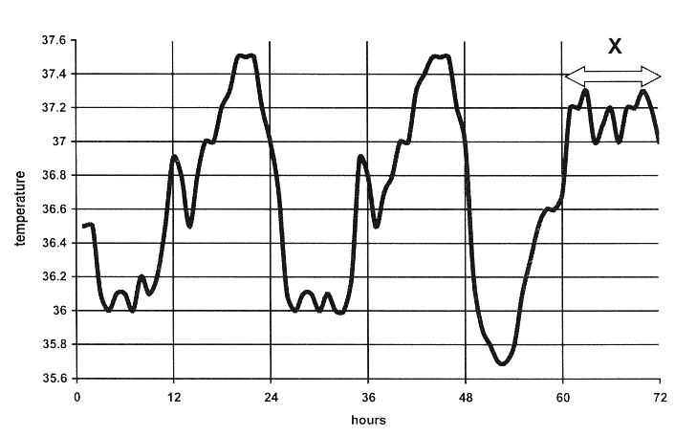
- SEC Sample Paper HL 6. The graph shows the variations in human body temperature over a number of days.
What was the minimum temperature recorded? ............................................................
What was the maximum temperature recorded?............................................................
Suggest a reason for the difference between body temperature during period X and the
same period on the previous days...........................................................................................
What is the source of the heat that keeps the body at a fairly constant temperature?
State two responses that result when body temperature begins to drop.
1 ………………………….............................................................................................................
……………………………………………………………………………………………….
2 .......................................................................................................................................................
.......................................................................................................................................................
Explain briefly how sweating assists in the shedding of excess heat . ............................................................
…..…………………………………………………………………………………………………………
………..……………………………………………………………………………………………………
……………..………………………………………………………………………………………………
………………..……………………………………………………………………………………………
Possible Answer

- 2011 HL 4. (a) (i) What is an endotherm? __________________________________________________________
(ii) What word is used to describe animals which are not endotherms?
____________________________________________________________________________
(iii) Suggest an advantage of being an endotherm. ________________________________________
(b) The graph shows daily variations of human body temperature over three days.
DAY 1 DAY 2 DAY 3
(i) What is the maximum range of body temperature under normal conditions as shown in the
graph?
_____________________________________________________________________________
(ii) At what time each day does body temperature drop to its lowest level? ____________________
(iii) Suggest a reason for the drop in temperature at the time referred to in (ii).
_____________________________________________________________________________
(iv) Children typically have higher body temperatures than adults. Suggest a reason for this.
_____________________________________________________________________________
Answer
- 2004 HL 12. (a) What is homeostasis? State the role of the kidneys in homeostasis. (9)
Answer

- 2007 HL 15. (c) (i) What is homeostasis? Note one reason why it is important in the human body.

- 2009 HL 15. (c) Write notes on three of the following topics:
(iii) Homeostasis.
Answer

1. 2004 HL Sample Q6
6. | (a) | min 35.7 | 3
 | (b) | max 37.5 | 3
 | (c) | period of exercise/ illness/ anxiety | 3
 | (d) | metabolic reactions/ in liver | 3
 | (e) | shivering/ blood vessels in skin constrict/ hairs rise/ sweating stops/ metabolism increases Any 2 | 3+2
 | (f) | sweat evaporates (causing body temperature to lower). | 3

- 2011 HL Q4
4. |  |  | 6 (3) + 2
 | (a) | (i) | (An animal that) produces its (or own or body) heat or (body) temperature independent of (temperature of) environment
 |  | (ii) | Ectotherms
 |  | (iii) | (Temperature always suitable) for good enzyme activity or maintains constant body temperature or activity independent of environmental temperature
 | (b) | (i) | 35.7°C to 37.6°C or 1.9°C or 36°C to 37.6° or 1.6°C
 |  | (ii) | (Any quoted time from) 3 a.m. to 6 a.m. inclusive
 |  | (iii) | Low metabolism (or explained) or sleep (or inactivity)
 |  | (iv) | High metabolism or growing (or more cell division) or more active or more infections or teething

- 2004 HL Q12
12. | (a) |  | Maintaining (a constant) internal environment or described  Role of kidneys: Maintaining salt balance or explained /  Maintaining water balance or explained /  [Note: Osmoregulation = 2 points] | 3  3  3

2007 HL Q15(c)
Homeostasis: maintenance / of constant internal environment or two  named factors constant  Reason: allows normal metabolic activities or example or keeps  temperature suitable for enzyme reactions | 2(3)  3

2009 HL Q15(c)
(iii) | Maintenance of / constant internal environment / example how /  example why  (Example = pH, solute concentrations or examples of such solutes, temperature, water)

